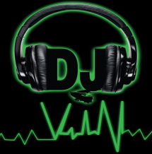
Typical Bridal Dance Set List

1st Dance (Bride & Groom)

___________________________________________________________

2nd Dance (Bride with Father)

___________________________________________________________

3rd Dance (Entire Wedding Party)

___________________________________________________________

4th Dance (Optional) example: Groom-Mother, Bride-Grandfather, etc…

___________________________________________________________

Normally at this time the DJ will play one additional slow dance song and invite everyone onto the dance floor. Then the DJ will play a fast party song to keep everyone on the dance floor.

The following types of events are / are not taking place…

Garter / Bouquet Toss Y_ / N_

Dollar Dance Y_ / N_

Grand March Y_ / N_

The following songs are / are not to be played…

Chicken Dance (Y / N) Hokey Pokey (Y / N) Electric Slide (Y / N)
Casper Slide (Y / N) Bus Stop (Y / N) Cupid Shuffle (Y / N)

Are requests allowed Y_ / N_

